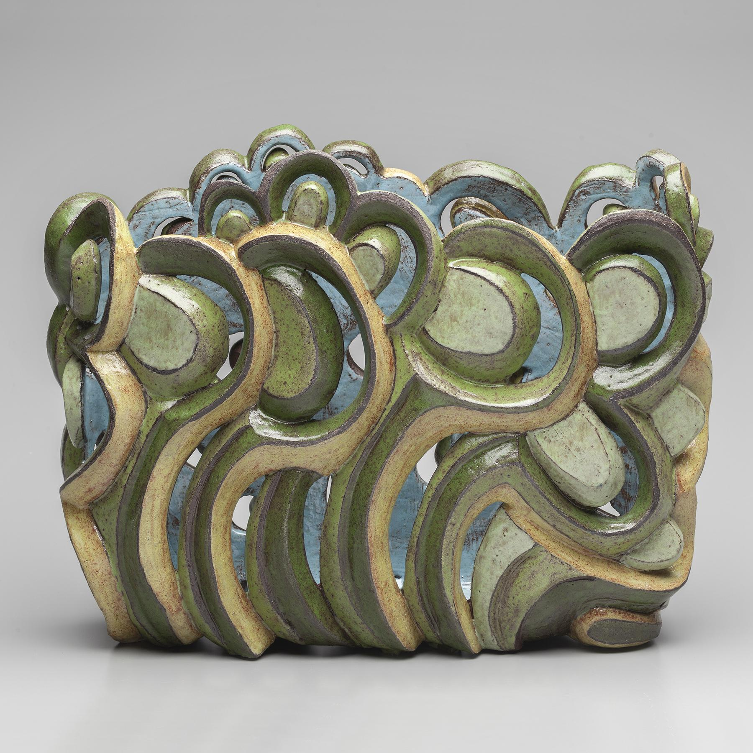
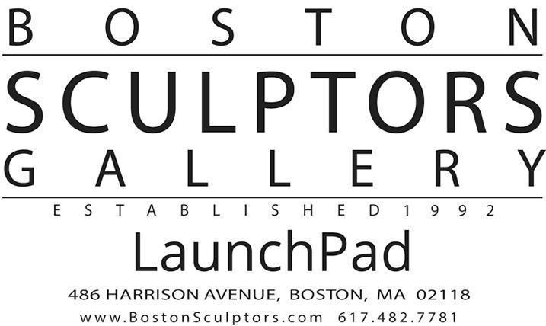

FOR IMMEDIATE RELEASE

Julie Peck: Meld
May 9 – June 9, 2024

Artist’s Reception & Talk
Saturday, May 11, 2 – 5pm with Talks at 3pm

First Friday: June 7, 5 – 8:30pm

Gallery Hours: Wednesday – Sunday, 11am – 5pm

Julie Peck’s exhibition Meld features new ceramic works that defiantly challenge the definition of a vessel. After creating functional ceramics for decades, Peck began to build larger sculptural forms during the quiet months of the COVID lockdown. The scale of the new work allowed for greater freedom of line, and the carving became less decorative and more referential. During that period, Peck also enjoyed weekly hikes in the woods, which began to inform her studio practice. The patterning of the trees and grasses, the colors of the lichen and rotting wood, and the light filtering through the canopy all made their impression in her forms and palette. Each piece became an interpretation of these landscapes, literally and emotionally. The vessel form remained important to her, as it represents both an inner and outer self. Yet, it was over a year before she realized her work no longer needed to hold water. Peck boldly began to cut into the walls, creating vessels that now hold light, just as the trees in the forest hold sunlight.

Julie Peck lives in Somerville, MA, creating her work in her basement studio, often with a parrot on her head! She has exhibited widely at both local and national venues. Peck holds an MFA from U-Mass Dartmouth’s Program in Artisanry. She has taught at Mudflat Pottery School for many years and recently began teaching at Indigo Fire Studio. Peck has received fourteen MCC STARS grants, funding large scale artist-in-residency projects in many local elementary and high schools.

# # #
Julia Shepley, BSG LaunchPad Gallery
617.628.7623
bostonsculptors@gmail.com
juliashepley@gmail.com
Julie Peck
juliepeckceramics@gmail.com
http://juliepeckceramics.com
IG: @juliepeckceramics
Contacts:

